Manufacturing, assembly and test procedures for the Athena Turbine v 1.64

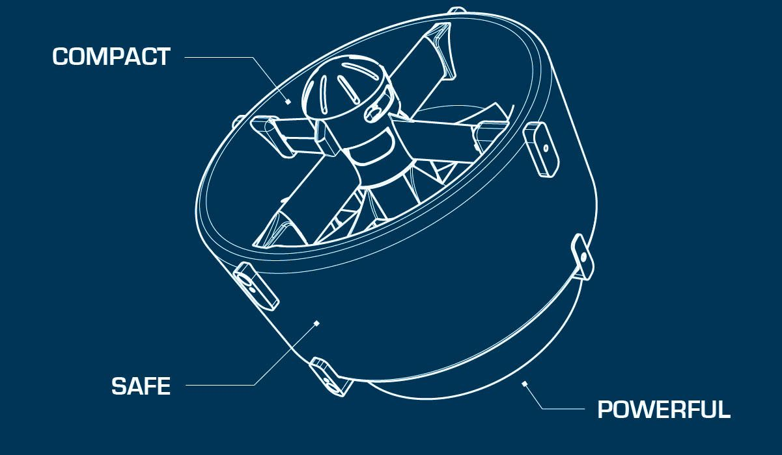

Table des matières

I- **Introduction** 3

II- **Lexique technique** 3

III- **Repartition du temps** 5

IV- **Impression des pièces et réglages des imprimantes** 5

V- **Fabrication des rotors : PROD-RTR** 7

VI-  **Fabrication des ensembles bras : PROD-ARM** 10

VII- **Assemblage rotors sur les ensembles bras : ASS-ARM** 12

VIII- **Fabrication du Shroud : PROD-SHRD** 16

Partie supérieure : SHRDSUP **Error! Bookmark not defined.**

Partie inférieure : SHRDINF **Error! Bookmark not defined.**

Assemblage de la partie haute et de la partie basse : ASS-SHRD **Error! Bookmark not defined.**

IX- **Finalisation de l’assemblage de la turbine Athena : ASS-TRB** 16

X- **Test de fonctionnement : TEST-TRB** 17

XI- **Peinture de la turbine : PNT-TRB** 18

# Introduction

Before starting the construction of a Athena turbine model, it is important to know which direction of rotation one wants: **CW ou CCW**. Indeed, despite the fact that the Athena turbines operate with 2 contra rotors, a torque following the axis of the motors is still apparent and is important enough to be taken into account. To determine whether a turbine is designated as CW or CCW, simply look at the inlet rotor from the top of the turbine. If this turns clockwise then the turbine is CW and is CCW if conversely.

It should also be known that the two rotors used in the same turbine are not the same. This must be taken into account when printing the blades, hubs and choosing the right screw (left or right) of the motor axes. So there are a total of four different types of rotors: **1CW inlet/1 CW Outlet** And **1CCW inlet/ 1 CCW Outlet**. It is easy to recognize the rotor inlet of the rotor outlet and thus the blades and hubs that comprise them: the rotor blades inlet have the thinnest base while for the outlet, the base is thicker.

This Report Describes all the steps that will make it possible to obtain a fully functional Athena model.

# Technical Lexicon

**Glossary of the code for the construction stages of the Athena Turbine:**

ADJ = Adjustment

ARM = Arm (part)

ASS = Assembly

BLD = Blade (part)

BNCH = Bench

CON = Connector

CRB = Carbon fiber

DRL = Drilling

DRML = Dremel

DRY = Drying

EPXY = Epoxy mix (resin + hardener)

ESC = Electronic Speed Controller

HUB = Hub (part)

LAY = Lay

M3 = M3 threaded rod

MTR = Motor

PARAM = Parameter

PLG = Plug (part)

PNT = Paint

PREP = Preparation

PROD = Production

RTR = Rotor (part)

SHRD = Shroud

SHRDINF = Shroud inferior

SHRDSUP = Shroud superior

SLD = Solder

SND = Sanding

SPR = Spacer bar

STK = Stickers

STRT = Start

TEST = Test

TIE = Tie (collar)

TRB = Turbine Athena

VERIF = Verification

WGT = Weight

WRE = Wire

# Repartition du temps

|  |  |  |  |
| --- | --- | --- | --- |
|  | **Opérations** | **Temps de séchage** | **Total** |
| Printing parts in 3d | 146 h | / | 146h |
| Production | 786 min = 13,1h | 51h | 64,1h |
| Assembly | 347 min = 5,78h | / | 5,78h |
| Tests | 45 min = 0,75h | / | 0,75h |
| Painting | 205 min = 3,42h | 48h | 51,42h |
|  | TOTAL = 169,05h | TOTAL = 99h | **TOTAL = 268,05h** |

Total working time to produce a turbine Athena, given for a single worker working 7h per day and assuming that all parts are already printed: 13.1 + 5.78 + 0.75 + 3,42 = 23,05H * = env 3d and a half

* Value Theoretical and Approximate.

**In reality and in practice, it will take about 10J between the turbine construction request and Sa Production output For a single worker working 7h per day 5d/7.**

# Printing parts and printer settings

**Approx time : 146 hours**

In order to print the parts correctly and flawlessly, it is essential to follow the following few rules:

-Impressions requiring a high temperature of the nozzle (> 250 °) as for polycarbonate or CPE must be done with a closed enclosure in order to preserve the heat generated by the printing tray. Failure to comply with this rule will create a deformation of the parts or the creation of micro cracks that weaken the workpiece.

-Likewise, and always in the context of impressions requiring high temperatures, it is important to turn off the printing fan (usually the largest of the fans and whose breath is directed towards the nozzle). Be careful not to turn off the extruder fan, which must always remain activated or damage the printer.

-Finally, for parts which always require a high temperature printing, the printing base in contact with the tray exceeds more than 2cmx2cm, use an adhesive sheet (no adhesive spray) to ensure that the first layers Adhere well to the plateau.

Ideal printers for the creation of precise and high-temperature parts such as arms, plugs, Blades: Ultimaker Series

To print the shrouds, a covered creality is recommended.

**Printing the shroud** :

Top shroud part with integrated plugs CPE on creality = 45 hours

Inside bottom shroud CPE on ultimaker = 25 hours

Outside bottom shroud CPE on creality = 25 hours

**Printing arms** :

Arm polycarbonate on ultimaker = 14 hours

**Printing Blades :**

Blade polycarbonate on ultimaker = 2 hours

**To be printed one at a time !**

**Printing hubs :**

Hub polycarbonate on ultimaker = 7 hours

**Printing plugs** :

Plugs black CPE on ultimaker = 5 hours/set (1 set is 2 fitted plugs)

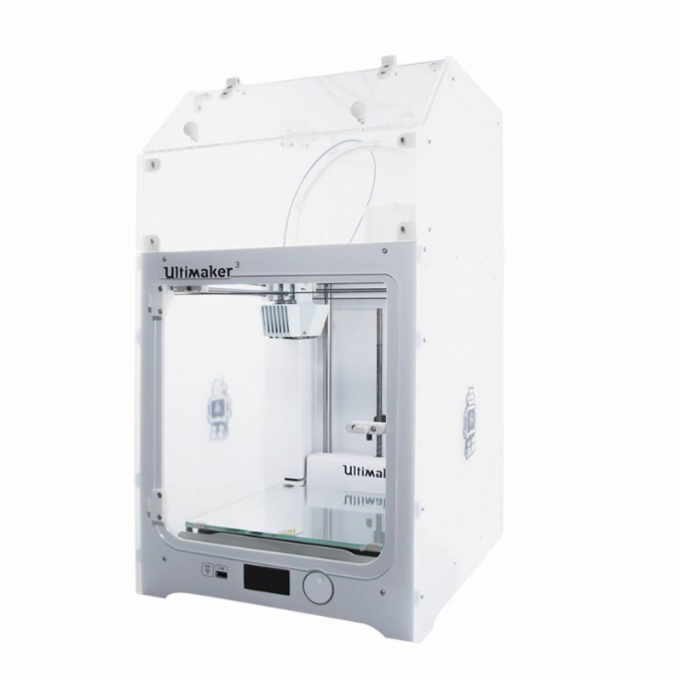

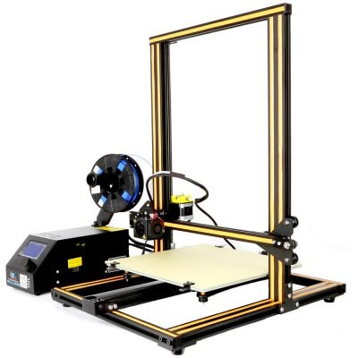

*Creality CR-10*  *Ultimaker 3 with cover*

# Manufacture of rotors: PROD-RTR

**Approx time : 125 min without drying**

**Necessary material:**

1. 1 Hub Inlet en polycarbonate
2. 1 Hub Outlet en polycarbonate
3. 5 Polycarbonate Inlet Blades
4. 5-Blade Polycarbonate Outlet
5. A drill with diam 6mm drill bit
6. A Dremel with tapered tip
7. One 6mm metal nut with locking with no screws
8. High Glue type Superglue
9. Sanding Paper Grain 240
10. A cutter
11. A hammer
12. An epoxy preparation with a ratio of 5:1 (epoxy resin and hardener)
13. Prep-HUB: At the output of the printer prepare the polycarbonate hubs by removing the printing residues using a cutter. (15 min each)
14. DRL-Hub: Using the drill and the diam 6mm drill bit mounted on it, adjust the diameter of the center hole of the hub in which the 6mm motor axis will pass. To do this, turn the drill in the opposite direction to the bit in order not to twist the hole that composes the hub. Operate delicately. (5 min each)
15. DRML-HUB: Use the Dremel and a tapered tip to skew the edges of the 6mm nut housing to facilitate insertion into the housing. (10 min each)
16. PREP-hub: Insert the nut into the hub. The easiest is to put the nut on a flat surface, then place the hub on the nut and face the housing and then hammer gently to push the nut into its housing. Avoid directly hammering the plastic, for example use a flat wooden wedge between the hammer and the hub. Be careful, the nut must be flat! (5 min each)
17. SND-BLD: At the output of the printer prepare the blades by sanding them lightly with the paper 240 on their surface. Attention they are extremely fragile. Also lightly sand their base until the blade can fit into its housing on the hub. Coat the housing with strong glue before mounting the blade. Fast because the glue dries quickly. (5 min each blade)

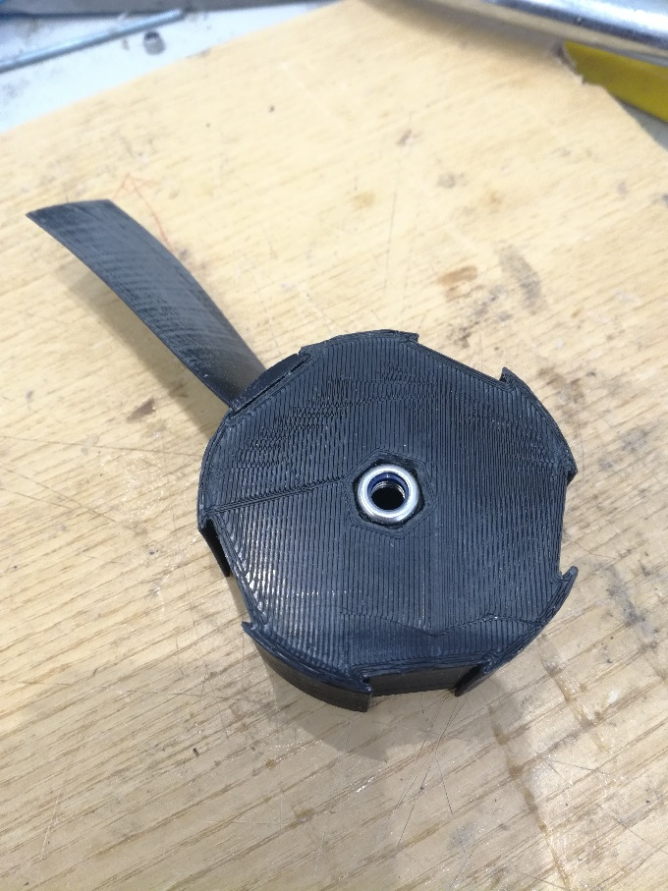

1. SND-Hub: Once the blades are mounted, sand the hub at the blade feet to level the surface. (10 min each)
2. 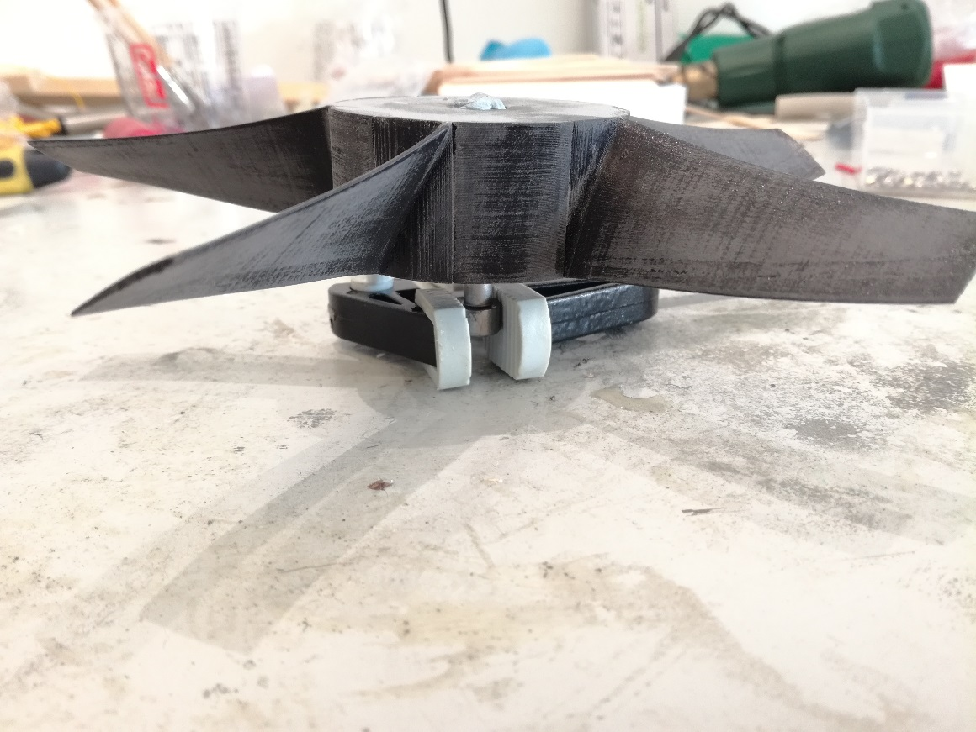PREP-EPXY : A l’aide d’un étau ou pince étau, mordre une vis de diam 6mm et venir visser partiellement le rotor sur cette vis. De cette manière nous pourrons aisément enduire le rotor d’epoxy sans contact avec les mains.
3. Prep-EPXY: Prepare an epoxy mixture with a ratio of 5:1.

Ex: for 5 units of epoxy resin added, a hardener unit must be mixed

4x**5**= 20g Epoxy resin 🡪 4g of Hardener and thus total 24g of mixing

20x**5**= 100g Epoxy resin 🡪 20g of Hardener and therefore total 120g of mixing

**Caution, wear gloves when handling with epoxy!**

1. 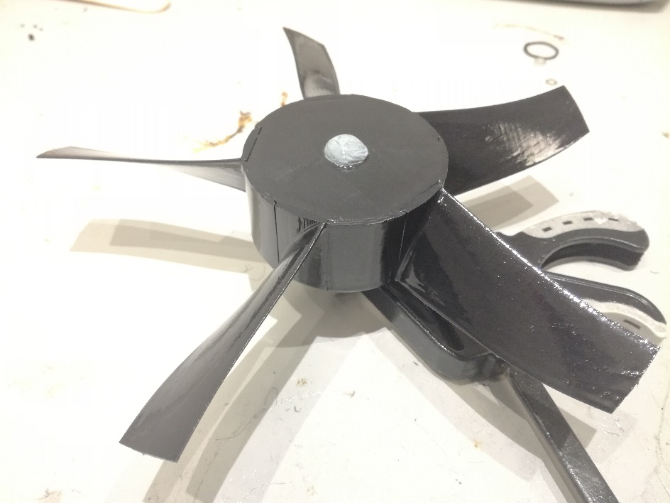EPXY-RTR: Coat the epoxy rotors with a brush. Do not overdo and exaggerate on the amount of epoxy: soaking the brush only once in the mixture is sufficient to cover a complete rotor. (10 min both)
2. Dry-EPXY: let dry overnight (12h at least)

# Manufacture of ARM sets: PROD-arm

**Approx time : 150 min without drying**

**Necessary material:**

1. 2 Polycarbonate-Printed arm assemblies
2. 4 single M3 Nuts without locking
3. 1 dia 3mm threaded rod
4. 1 Fine Clamp
5. 1 cutter
6. Sanding Paper Grain 240
7. An epoxy preparation with a ratio of 5:1 (epoxy resin and hardener)
8. 1 brush
9. Prep-arm: Prepare the arms on their way out of the printer using a cutter to eliminate printing overprints. To remove the 3d-printed media, including the bracket that covers the motor housing, take a rather fine clamp. Fit the clamp into the crevices of the bracket and turn. Repeat the operation until you remove any residual material that has been used to print the workpiece. (15 min each)
10. PREP-arm: Insert the 4 M3 nuts into each unit at the end of the arm. It will be easy enough to insert the nuts in both arms the thick but for the thinner arms, you must first file each of the 6 surfaces of the nut before inserting it. (20 min each)
11. PREP-ARM: Screw the M3 rod into each nut to check if it is not crooked
12. 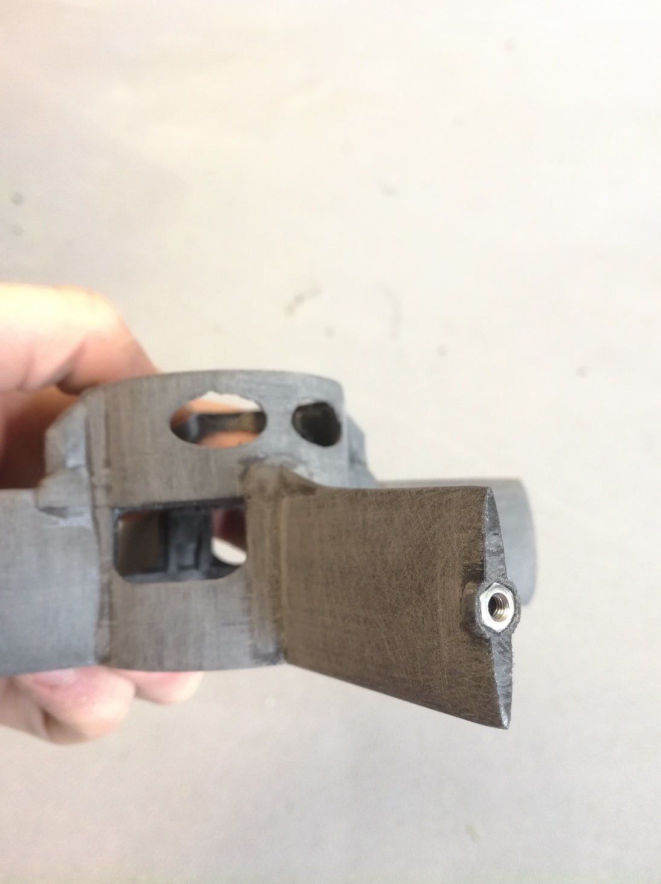SND-ARM : Sand arms to grain 240 to obtain smooth curves (30 min each)
13. Prep-EPXY: Prepare a support to suspend the arm assemblies when drying the epoxy.
14. Prep-EPXY: Prepare an epoxy mixture with a ratio of 5:1. For this pour 20g of resin for 4g hardener. This quantity is sufficient to coat 2 sets of arms.
15. EPXY-arm: Coat the arm assemblies with care not to insert epoxy into the threads of the nuts. (10 min both)
16. DRY-EPXY Let it dry one night (12 hours at least)

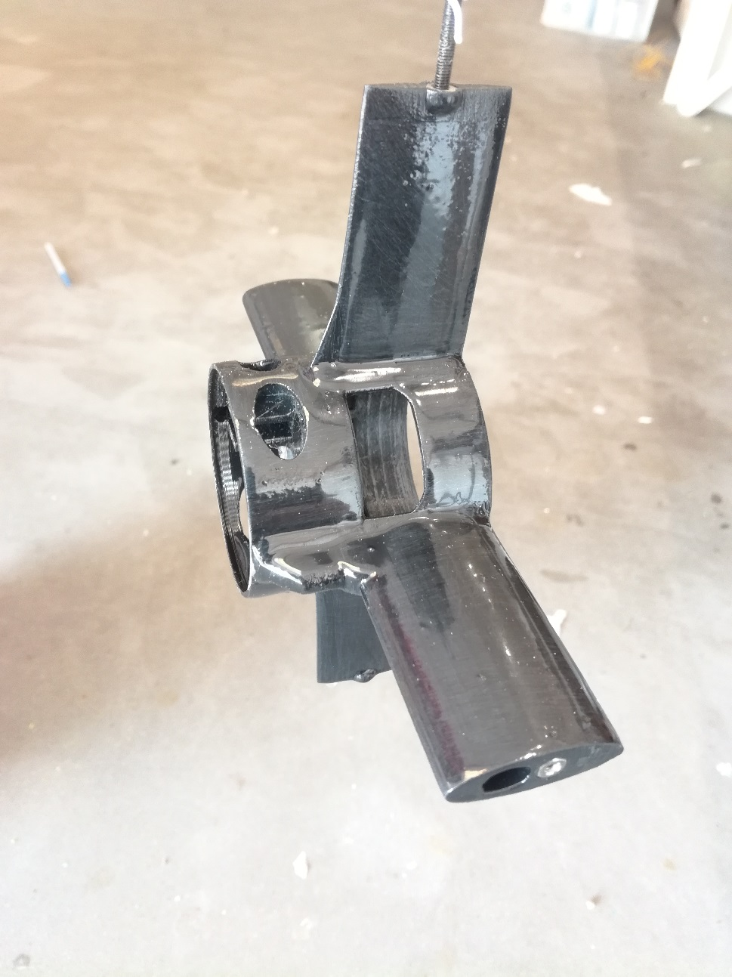

# Rotor assembly on ARM assemblies: SSA-arm

**Approx time : 162 min**

**Necessary material:**

1. 2 Assembled ARM sets
2. 1 rotor Inlet
3. 1 rotor Outlet
4. 2 Caps in polycarbonate to come cover the housing of the ESC
5. 2 MN4010 Tmotor Motors
6. 2 axes motor Tmotor 6mm (Be careful to check the direction of the thread)
7. 14 3mm Hex screw supplied in Tmotor kit
8. 2 ESC castle creation NoBEC
9. 1 Hex Screwdriver 2.5 mm
10. A wire cutter
11. A clip for stripping
12. 1 Soldering iron with tin
13. Heat shrink Sleeve
14. Red and black 14AWG silicone electric wire
15. Medium Strength Loctite (blue color)
16. PREP-MTR: Unpack the Tmotor motor shaft and check its length by placing it against the hub. It must not exceed and if it is the case file it until the desired length is obtained. Attention to the choice of the motor axis, to be chosen according to the direction of rotation of the rotor because some have one step of screw to the left and others one step of screw to the right. (from 2 to 15 min each)
17. PREP-MTR: Unpack the motor and mount its 6mm axis using the 3 fixing screws provided in the kit. Coat them with Loctite beforehand. (5 min each)
18. PREP-arm: Mater The 4 threads present on the arm assembly and which will be used to secure the motor. To do this, take one of the motor fixing screws and screw it gently until the thread is broken. Then unscrew it a bit and press the screw to smooth the hole. Repeat the operation for each of the 4 holes that will support the motor. (10 min each)
19. SSA-RTR-MTR: Screw the rotor onto the motor, being careful not to break the blades. This is one of the most delicate stages of construction. You have to go quietly and with a lot of precaution. (5 min each)

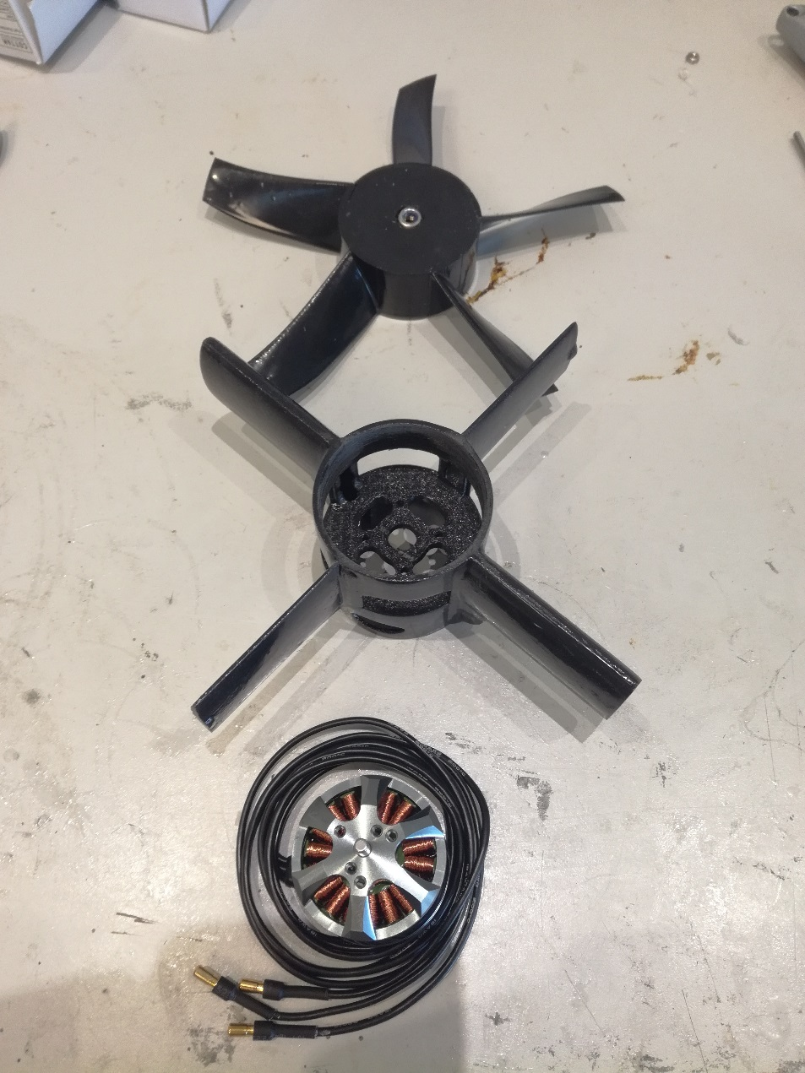

1. PREP-ESC : Unpack a castle ESC and using a cutting pliers come cut the plastic skirt that covers the 3 wires towards the motor. This will make it easier to insert the ESC into its housing. (2 minutes each)

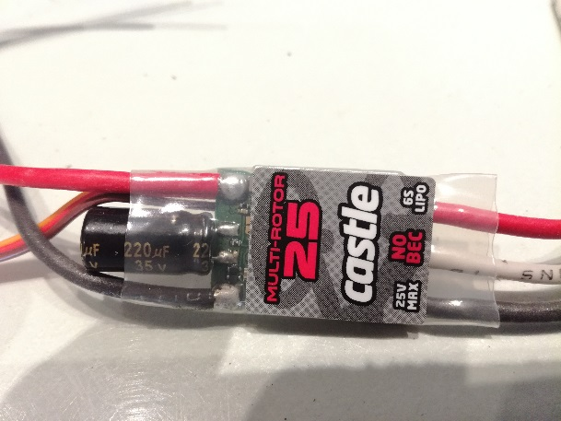 🡪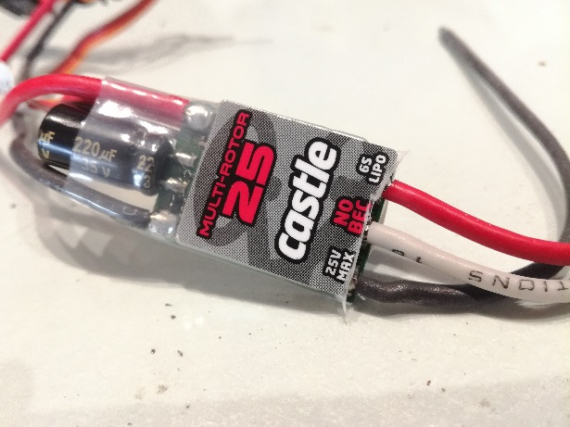

1. 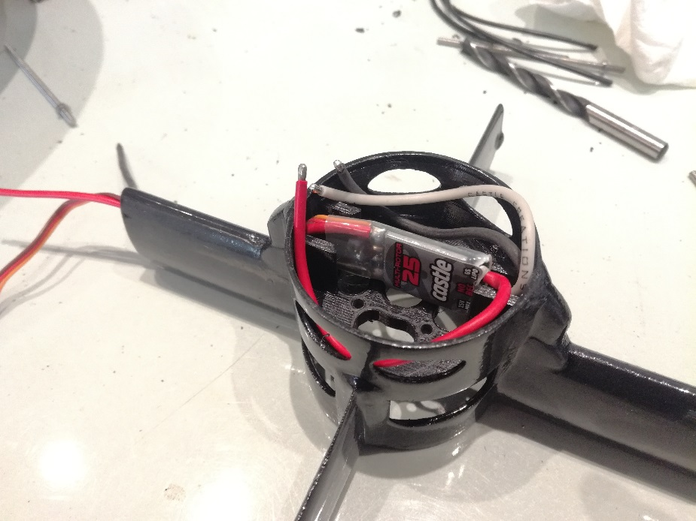ASS-ESC-ARM : Run the ESC cables (servo jack and wire to battery) into the arm as shown in the picture below. (2 minutes each)
2. ASS-ESC-ARM : Cut the 3 motor wires in half and pass them into the housing provided for them to arrive in the ESC compartment. (5 min each)

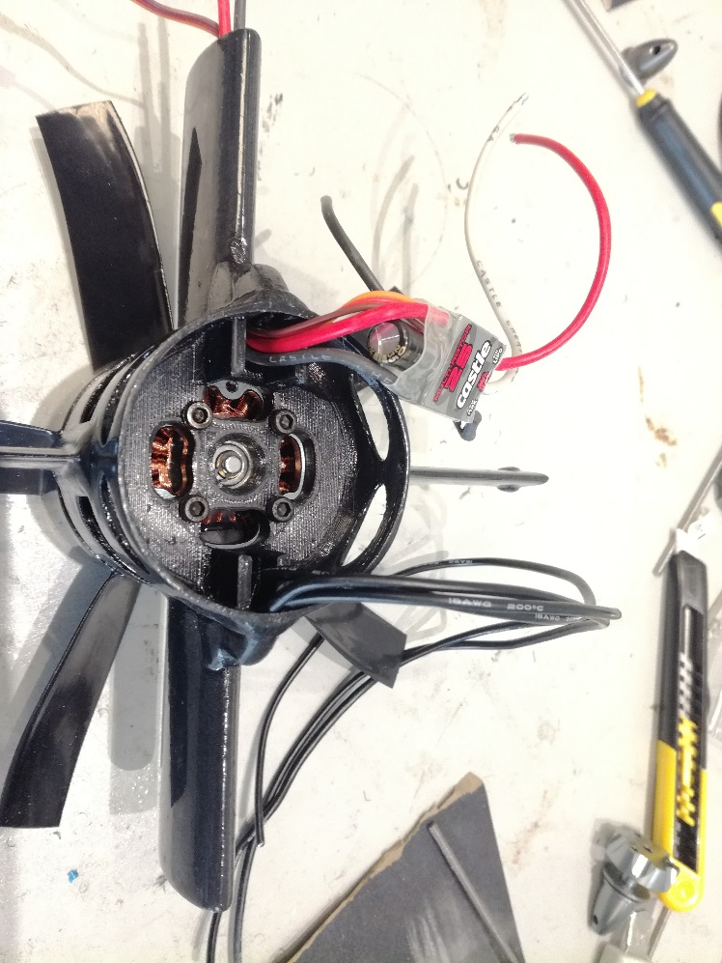

1. ASS-MTR-ARM : Screw the motor onto its support using the 4 hex M3 screws and apply loctite beforehand. (5 min each)
2. ASS-ESC-MTR : Adjust the motor and ESC wires to the correct length and solder them to the tin. The connection order does not matter. (15 min each)
3. 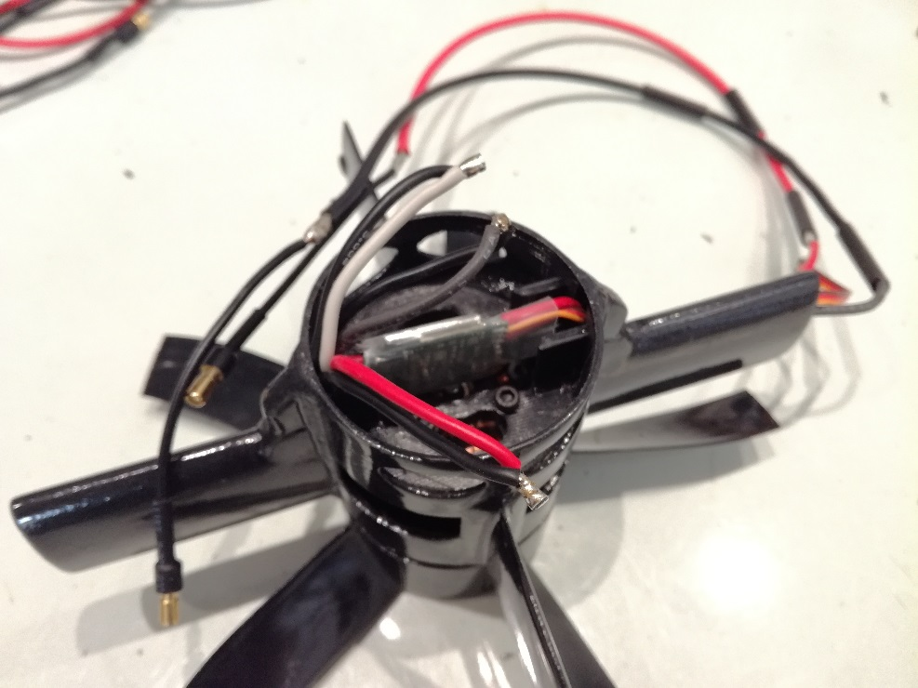PREP-ESC : Rallonger les fils de l’ESC qui vont vers la batterie de la longueur souhaitée. (15 min each)
4. PREP-ESC/PREP-MTR : Use heat shrink sleeve to mask areas where the wire is visible. (2 minutes each)
5. ASS-ESC-ARM : Press the Polycarbonate caps (hats) on the ESC housing.

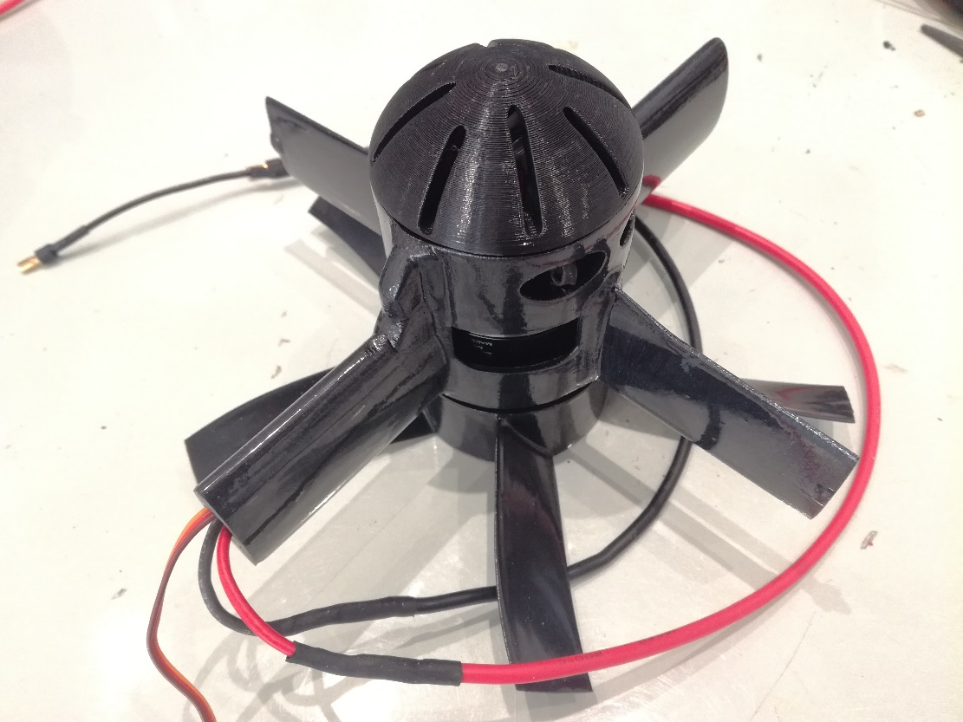

# Fabrication du Shroud : PROD-SHRD

1. TO BE UPDATED WITH NEW PROCEDURE / MAKE A SEPARATE FILE ONLY FOR THE SHROUD

# Finalization of the Athena turbine assembly: SSA-TRB

**Approx time : 185 min**

**Necessary material:**

1. 2 Threaded Rods M3
2. 4 Connectors 3mm Male
3. Heat shrink Sleeve
4. A soldering iron with tin
5. A hacksaw
6. A file
7. 8 single M3 nuts without locking
8. High Glue type Superglue
9. PREP-M3: Cut the M3 threaded rods into eight pieces: 4 pieces of length 64mm and 4 pieces of length 85mm. These will be used to maintain the arm-rotor assemblies in the shroud. 1h
10. 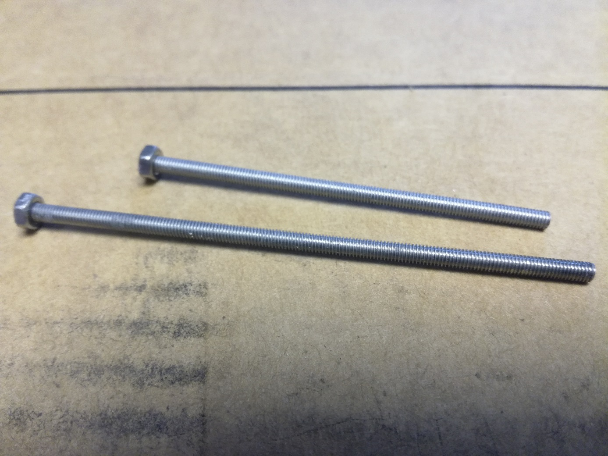PREP-M3 : Glue a M3 nut to one end of each piece of threaded rod with the superglue. (20 min)
11. ASS-SHRD-ARM : Position the ARM/rotor assembly in the shroud and run the ESC cables through the holes provided for this purpose. (30 min)
12. SLD-CON : Solder the 3mm male connectors to the ESC leads that go in the direction of the battery. (45 min)
13. 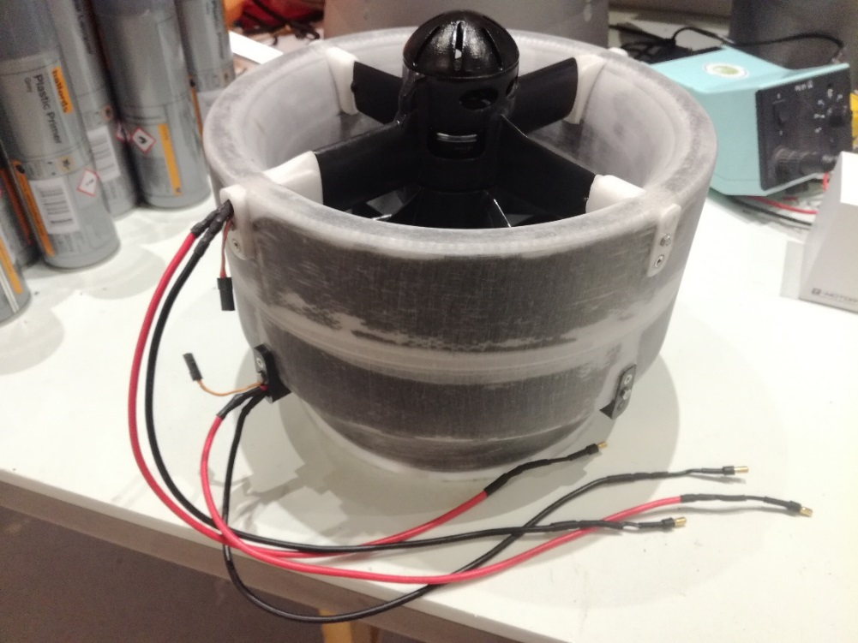ASS-SHRD-ARM : Attach the arm-rotor assembly to the shroud thanks to the rods previously cut in accordance with the following rule: the rods of length 64mm are intended for the thinnest arms and those of 85mm long to the thickest arms. At this stage the rotors should always be well coaxial and the blades must not touch the inner surface of the shroud. (30 min)

The Athena turbine is now fully assembled. Now up to the test of good functioning

# Test run: Test-TRB

**Approx time : 45 min**

**Necessary material:**

1. A voltage supply for each motor and remote controllable.
2. A remotely controllable PWM signal generation system
3. A test bench that allows the turbine to be fixed
4. A force sensor
5. A data acquisition system
6. Neva Aerospace software for displaying collected data
7. SSA-TRB-BNCH: Mount the turbine on the test Bench (5 min)
8. WRE-TRB: Connect the ESC's power cables and signal cables. Attention to Polarity! (5 min)
9. PARAM-ESC: Set ESC with the software and thanks to the transmission via WiFi the voltage delivered by the voltage generators. (10 min)
10. 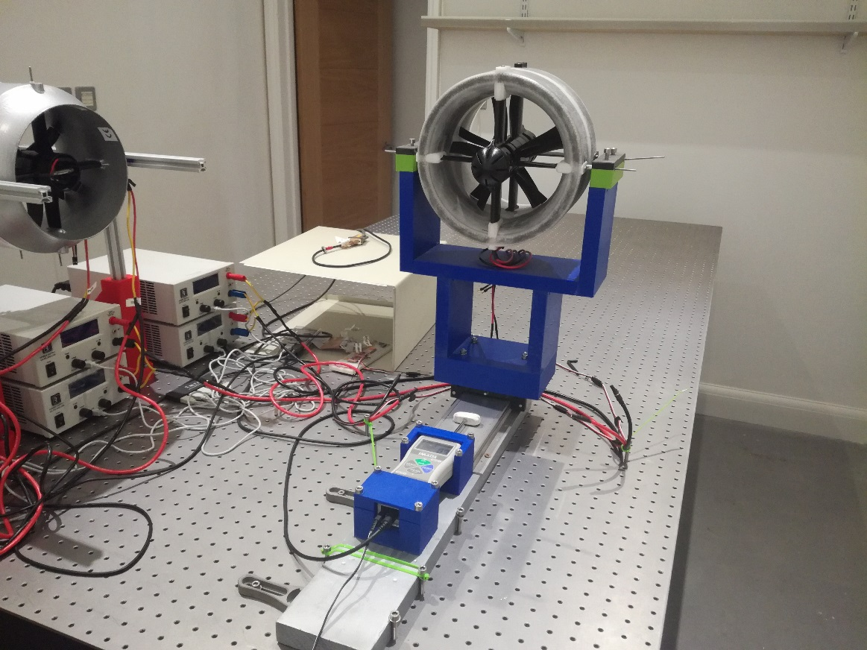VERIF-WRE : Check that everything is properly plugged in and do a visual inspection of the rotors and shroud to prevent damage to the turbine. (5 min)
11. Leave the test space of the turbine before switching on
12. STRT-Test: Launch the automated turbine test program. (20 min)
13. Observe the results obtained and verify that they correspond to the models already obtained in previous tests with the same turbines.

# Peinture from turbines: PNT-GRT

NEW PROCDURE – External contractor: Prepare turbines for external contractor

TO BE DONE

OLD PROCEDURE: Painting in-house

**Approx time : 205 min without drying**

**Necessary material:**

1. 1 Aerosol of Special Grey Plastic Primer (400ml)
2. 1 Spray of special glossy white plastic paint (400ml)
3. 1 Aerosol Clear Gloss varnish
4. 1 sticker Neva Aerospace
5. 1 sticker « this side up »
6. 1 sticker "Do not insert hands in turbine"
7. An insulated part of the wind, with a constant temperature of 20 °c and a humidity not exceeding 50%
8. PREP-NTP: disassemble the turbine rotors so as to keep only the shroud. (15 min)
9. PREP-NTP: Check the surface state of the plastic component of the shroud. This should not have any irregularity, must be clean and well smooth. This step was normally performed in the "SSA-SHRD" section, Step 10, page 21.
10. PREP-NTP: Hide the arm support faces on the plugs with paint tape, and make sure the threads are masked too. (15 min)
11. Prep-NTP: Prepare a flat stand or place the turbine in the area, and in the room where you are going to paint.
12. NTP-SHRD: Follow the instructions on the spray primer. Shake for 3 min and spray on all surfaces of shroud. The first layer should be fine. Wait 15 minutes between each layer. Spray 2 coats evenly on all surfaces. (25 min)
13. Dry-NTP: Allow to dry for 30 min
14. NTP-SHRD: Follow the instructions shown on the paint spray. Shake for 3 min and spray on all surfaces of shroud. The first layer should be fine. Wait 15 minutes between each layer. Spray 3 coats evenly on all surfaces. (45 min)
15. Dry-NTP: Allow to dry at least 24h
16. LAY-STK: Once the paint is dry, glue the stickers in place directly to the paint. (5 min)
17. NTP-SHRD: Follow the instructions shown on the varnish aerosol. Shake for 3 min and spray on all surfaces of shroud. Spray in 1 layer being careful not to over-emphasize in the same place. (10 min)
18. Dry-NTP: let dry 24h
19. SSA-TRB: Raise your Arms in the Shroud (15 min)
20. Test-TRB: Proceed to a bench test again. (45 min)

Example of Athena turbines mounted on the prototype Wohler B Mark III